An Approach for RAG Performance Improvement Based on User Requests Predicting and Interests Modelling

Nikolay Butakov, Ilya Popov
National Research University ITMO
Saint Petersburg, Russian Federation
ilya.s.popov@mail.ru

Abstract— This study investigates methods for generating contextually relevant subsequent questions in reading-comprehension dialogue systems. Using a dataset of dialogues each containing exactly 20 questions alongside their source passages and ground-truth answers, we propose and evaluate two distinct approaches for predicting a user's future questions within a dialogue. The first approach extracts question-sequence patterns from 1,000 dialogues, clusters them into nine semantic clusters using sentence embeddings, and uses the cluster description to guide question generation. The second approach identifies unaddressed factual spans directly in the source passage and generates questions grounded in those spans, matching the speaker's conversational style. Evaluation is conducted using an LLM-as-a-judge. Metric used is Hit Rate, the percentage of target questions successfully predicted with an exact-match score. The pattern-based approach achieves a Hit Rate of 3%, while the span extraction approach achieves 19.8% at a 60% context split, rising to 33.5% when only 20% of questions are provided as context. The results demonstrate that grounding generation in specific, verifiable passage spans substantially outperforms abstract stylistic pattern matching, and that the predictability of remaining questions decreases as more of the dialogue is consumed as context.

Introduction
Dialogue systems increasingly rely on predictive capabilities to anticipate user needs and provide proactive assistance. Understanding the sequential nature of human questioning, where subsequent queries often build upon previous context, is crucial for developing responsive conversational agents. This paper introduces and compares two methodological approaches for question prediction within this conversational framework:
- Pattern-based clustering: This approach operates at the level of question-sequence structure rather than passage content. It first processes a large corpus of 100 dialogues to extract the characteristic question pattern of each (e.g. "general-to-specific", "character-focused deepening", "drill-down chain"). These patterns are embedded into a semantic vector space and clustered. For a new incoming dialogue, its first N% of questions are classified into the closest cluster, and the cluster's structural description is used to guide a language model to generate the remaining questions.
- Passage span extraction: This approach grounds question generation directly in the source text. A language model analyses the passage alongside the already-asked Q&A pairs, and extracts candidate answer spans about which questions have not yet been asked. A second language model then converts each span into a question phrased in the speaker's exact conversational style. Evaluation is performed by an LLM-as-a-judge that compares each generated question's target span against the ground-truth answer of the corresponding real question.
II. Literature overview
The task of automated Question Generation (QG) is defined by key methodological choices, primarily the scope of the input context and the dependency on a target answer. Context can be provided at a paragraph level, utilizing full textual passages, or at a keyword level, operating on a set of core terms. Furthermore, QG approaches are categorized as either answer-aware or answer-agnostic [1]. Answer-aware methods take a known answer as input and generate a corresponding question grounded in a provided context. Answer-agnostic methods generate questions directly from the context without a pre-specified answer target [2]. In paper [3] authors in order to generate questions, first use LLM to generate an answer plan based on the given context and predefined requirements. This plan contains several candidate answers or answer-containing sentences. During the last step, generated plan, context and prompt are given to the QG models to generate question-answer pairs. Answer-agnostic approach in paper [4] used 100 different texts from different domains to generate multiple questions from each text.
Rather than generating questions from raw text alone, leveraging explicit topic representations provides a structured semantic framework that guides the generation process toward more coherent, focused, and contextually appropriate inquiries [5]. Zhang et al. [6] combine topic modeling and large language models (LLMs) to generate questions from large volumes of user feedback. Each topic is represented as a probability distribution over all words in the vocabulary, so authors use only top words with the highest probabilities to describe a topic. These topics are then used to find documents that are semantically similar to the them, to further feed them to the LLM to generate a natural-language question. In work [7] CoQA dataset is used as a training data for transformer model. Using BERTopic [8] topics are extracted as a cluster of related keywords from the conversation history, which includes both questions and answers. Then extracted topics, question-answer pairs and text context are used to generate next question in a conversation.
To evaluate generated questions quality metrics like BLEU [9], BERTScore [10], ROUGE [11] are often used in research [2, 3, 12]. Another approach is to use LLM-as-a-judge [13]. In paper [14] LLM-as-a-judge is used to compare answers to generated questions. Specific prompts are used focusing on semantic quality only (ignoring formatting, tone, etc.) and evaluation results are aggregated using a scoring system.
III. Methodology
In this research CoQA dataset is used. The dataset contains 7199 dialogues with different number of questions each. Questions are interconnected, often relying on context from previous turns in the dialogue. To conduct a controlled experiment, this study specifically analyzes the subset of dialogues containing exactly 20 questions. To control the proportion of context provided to the model, the questions are divided at a configurable split point: the first N% are designated as prompt questions (PQ) and provided as context, while the remaining (100 − N)% serve as evaluate questions (EQ) and constitute the prediction target (Fig. 1). Unless otherwise stated, experiments use N = 60, yielding 12 PQ and 8 EQ per dialogue.
The LLM used in this research is gpt-oss-120b. The workflow is orchestrated using n8n.
A. Pattern-based clustering approach
The first approach models question prediction as a structural classification problem. Rather than reading the source passage, it operates solely on the patterns of question sequences observed across a large corpus.
In the first stage, 100 dialogues are each processed by an LLM prompted to identify the dominant question-sequence pattern of that dialogue, a concise label such as "general-to-specific cascade", "character-focused exploration", or "progressive drill-down chain". This produces a vocabulary of pattern labels, one per dialogue.
In the second stage, all unique pattern labels are encoded using the all-mpnet-base-v2 sentence transformer model and L2-normalised. The optimal number of clusters k is determined by maximising the silhouette score over a range of k from 2 to 11. Both KMeans and Agglomerative clustering (cosine distance, average linkage) are applied at the optimal k. UMAP is used to produce a two-dimensional projection for visual inspection. This procedure yields nine clusters (n = 4 to n = 42 dialogues per cluster), each characterised by a shared question-sequence structure.
In the third stage, for a new dialogue, its PQ are passed to an LLM that classifies the dialogue into one of the nine clusters. The cluster's structural description — including its primary patterns, typical question types, and a prediction of what the remaining 40% of questions likely covers — is then passed alongside the PQ to a second LLM that generates the EQ. The generated questions are subsequently compared against the real EQ using the evaluation procedure described in Section IV.
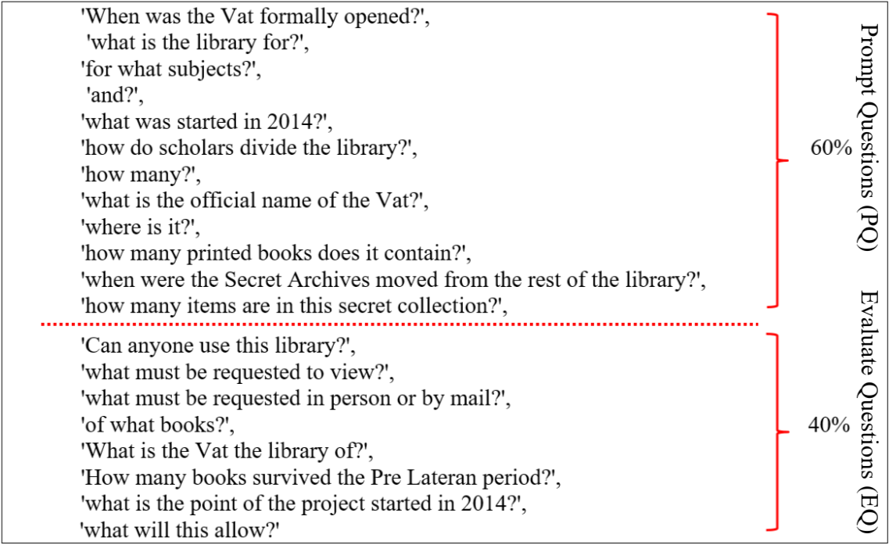
Fig. 1. An example of dividing a set of questions into parts
B. Entity extraction Approach
The second approach abandons abstract pattern classification in favour of grounding question generation in specific, verifiable facts from the source passage. The pipeline comprises three LLM stages: span extraction, style-aware question generation, and LLM-as-a-judge evaluation.

Span extractor LLM
The span extractor receives the full source passage alongside the PQ paired with their ground-truth answers (the PQ+A block). Its task is to identify facts in the passage that have not yet been addressed by any question in the PQ set.
The extractor then collects candidate answer spans, exact phrases or short clauses from the passage. Each span is annotated with its answer type (person, location, time, count, yes-no, attribute, quote, or action), a one-sentence context description, and a momentum label indicating how closely it follows from the final PQ+A pair. The extractor is required to produce at least as many candidate spans as there are EQ to generate.
The extractor also characterises the speaker's conversational style from the PQ: average question length, whether the speaker uses elliptical follow-ups (bare "why?" or "and?"), the proportion of yes/no questions, and whether the speaker refers to entities by pronoun rather than full name.

Style Generator LLM
The style generator receives the candidate answer spans alongside the style characterisation derived from the PQ. Its sole task is to convert each span into a question that sounds like the same speaker who asked questions 1 through N. It does not read the passage or select topics; those decisions were made upstream.
The generator is constrained by explicit style rules: question length must match the characterised average; the yes/no phrasing rate must approximate the observed rate in the PQ; elliptical follow-ups must be used where the speaker's style calls for them; pronouns must be used where the speaker avoids repeating full entity names. The output is a numbered list of exactly (100 − N)% questions, starting from question N + 1.

IV. Results and conclusion
A. Evaluation Metric
To evaluate the effectiveness of each approach, Hit Rate (HR) is calculated::
$$HR=\frac{1}{N}\sum_{i=1}^{N}{\left(\frac{T_{i}}{M}∙100\%\right)}$$
where N is the total number of dialogues, Tᵢ is the number of successfully predicted test questions in dialogue i with an exact-match score (score 3), and M is the total number of EQ per dialogue.
Evaluation is performed by an LLM-as-a-judge. For each dialogue, the judge receives the real EQ paired with their ground-truth answers, and the generated questions paired with the passage spans they were built from. For each real question, the judge finds the best matching generated question and scores the pair on a 0–3 scale:
- Score 3: same passage span, the real answer and the generated question's target span come from the same sentence or clause; the questions are interchangeable.
- Score 2: same passage region, both questions draw from the same paragraph but extract different pieces of information, or one confirms what the other names.
- Score 1: same named entity, different fact. Both questions reference the same character or event but probe different facts about it.
- Score 0: no meaningful connection.
Only score-3 pairs count toward the Hit Rate. Each generated question may be matched to at most one real question.

Approach comparison
Both approaches were evaluated on the same 50 dialogues with N = 60 (12 PQ, 8 EQ per dialogue). Results are shown in Table I.
TABLE I. Hit Rate comparison across question generation approaches
Approach | Avg num of predicted | EV
Pattern-based | 0,24 | 3,0%
Entity-based | 1,58 | 19,8%

The span extraction approach outperforms the pattern-based approach by a factor of 6.6 on Hit Rate. The poor performance of the pattern-based approach can be explained by the fundamental mismatch between what the cluster captures and what is needed for prediction. Clusters group dialogues by the structural shape of their question sequences, whether questions proceed from general to specific, or focus progressively on a single character. This structural information does not tell the generator which specific topics, entities, or facts the speaker will ask about in the remaining 40%. Two dialogues classified into the same "general-to-specific" cluster may be about entirely different subjects, and the cluster description provides no signal about which passage facts remain unasked.
The span extraction approach succeeds precisely because it bypasses this level of abstraction. By reading the passage and identifying which specific entities have not yet been questioned, it presents the generator with concrete answer targets. The generator's task is then reduced to phrasing, it does not need to infer what topics exist, only how to ask about a fact it has already been shown.
Analysis of the 15 dialogues where the span extraction approach produced no score-3 pairs reveals three recurring failure modes. Different questions are generated about the correct entities. That is, the topic of the question is the same, but they ask about different facts. Second one is generated questions ask about entities that are present in the text, but about which no questions were actually asked. And in one dialogue, the questions went beyond the provided text. In it, the text is an excerpt from a book, and the model generated questions that touch on context from other parts of that book.

Effect of context split
To assess how the amount of provided context affects prediction quality, Approach 2 was evaluated across four split ratios on the same 50 dialogues. Results are shown in Table II.

TABLE II. Hit Rate of Approach 2 across context split ratios
Context given (N%) | EQ per dialogue | Avg num of predicted | Hit Rate
20% | 16 | 5,36 | 33,5%
40% | 12 | 3,92 | 32,7%
60% | 8 | 1,58 | 19,8%
80% | 4 | 0,62 | 15,5%

Hit Rate is stable at approximately 33% for 20 - 40% context, then drops to approximately 16 - 20% at 60 - 80%. The average amount of predicted questions decreases monotonically as the test set shrinks, reflecting the smaller number of questions to predict rather than degraded model performance; Hit Rate is therefore the appropriate normalised metric.
The decline at higher split ratios reflects a compositional property of the dialogues: the first questions in a dialogue tend to address the most salient and predictable facts in the passage, while later questions probe increasingly peripheral details. When 80% of questions are provided as context, the remaining 4 EQ are precisely those peripheral questions that are harder to predict even with greater contextual information. This suggests a diminishing-returns relationship between context and predictability, and indicates that providing only 20 - 40% of the dialogue as context is a practically efficient operating point for the span extraction pipeline.

References
- Zhang, R., Guo, J., Chen, L., Fan, Y., Cheng, X., 2021. A review on question generation from natural language text. ACM Transactions on Information Systems (TOIS) 40, 1–43.
- Lopez, L.E., Cruz, D.K., Cruz, J.C.B., Cheng, C., 2020. Simplifying paragraph-level question generation via Transformer language models. https://doi.org/10.48550/arXiv.2005.01107
- Li, K., Zhang, Y., 2024. Planning first, question second: An llm-guided method for controllable question generation, in: Findings of the Association for Computational Linguistics ACL 2024. pp. 4715–4729.
- Al Faraby, S., Romadhony, A., Adiwijaya, 2024. Analysis of LLMs for educational question classification and generation. Computers and Education: Artificial Intelligence 7, 100298. https://doi.org/10.1016/j.caeai.2024.100298
- Karri, P., Reddy, G., Vignesh, D., Pavan, A., Vamsi, T., Rishi, K., Kumar, K., 2025. Automated Question Paper Generator Using LLM. International Journal of Research and Innovation in Applied Science X, 266–275. https://doi.org/10.51584/IJRIAS.2025.10040020
- Zhang, D., Wang, J., Nayak, R., Bashar, M.A., 2024. Topic Models Meet LLMs: Generating Insightful Questions from User Feedback, in: The 22nd Australasian Data Science and Machine Learning Conference.
- Mulla, N., Gharpure, P., 2023. Genetic Algorithm Optimized Topic-aware Transformer-Based Framework for Conversational Question Generation. Procedia Computer Science 230, 914–922. https://doi.org/10.1016/j.procs.2023.12.041
- Grootendorst, M., 2022. BERTopic: Neural topic modeling with a class-based TF-IDF procedure. arXiv [cs.CL]. https://doi.org/10.48550/ARXIV.2203.05794
- Papineni, K., Roukos, S., Ward, T., Zhu, W.-J., 2002. Bleu: a method for automatic evaluation of machine translation, in: Proceedings of the 40th Annual Meeting of the Association for Computational Linguistics. pp. 311–318.
- Zhang, T., Kishore, V., Wu, F., Weinberger, K.Q., Artzi, Y., 2019. Bertscore: Evaluating text generation with bert. arXiv preprint arXiv:1904.09675.
- Lin, C.Y.: ROUGE: A package for automatic evaluation of summaries. In: Text Summarization Branches Out. pp. 74–81. Association for Computational Linguistics, Barcelona, Spain (Jul 2004), https://www.aclweb.org/anthology/W04-1013
- Pan, B., Li, H., Yao, Z., Cai, D., Sun, H., 2019. Reinforced Dynamic Reasoning for Conversational Question Generation. https://arxiv.org/abs/1907.12667
- Chiang, C.-H., Lee, H.-Y., 2023. Can large language models be an alternative to human evaluations? https://arxiv.org/abs/2305.01937
- Chen, G.H., Chen, S., Liu, Z., Jiang, F., Wang, B., 2024. Humans or llms as the judge? a study on judgement biases. https://arxiv.org/abs/2402.10669
- Reddy, S., Chen, D., Manning, C.D., 2018. CoQA: A Conversational Question Answering Challenge. https://arxiv.org/abs/1808.07042
- [16] Qwen, Yang, A., Yang, B., Zhang, B., Hui, B., Zheng, B., Yu, B., Li, C., Liu, D., Huang, F., Wei, H., Lin, H., Yang, Jian, Tu, J., Zhang, J., Yang, Jianxin, Yang, Jiaxi, Zhou, J., Lin, J., Dang, K., Lu, K., Bao, K., Yang, K., Yu, L., Li, M., Xue, M., Zhang, P., Zhu, Q., Men, R., Lin, R., Li, T., Tang, T., Xia, T., Ren, Xingzhang, Ren, Xuancheng, Fan, Y., Su, Y., Zhang, Y., Wan, Y., Liu, Y., Cui, Z., Zhang, Z., Qiu, Z., 2024. Qwen2.5 Technical Report. https://arxiv.org/abs/2412.15115.

